# The Companies of Schwarz Group are Increasing Their Pay for Apprentices, High School Graduate Program Participants and Integrated Degree Program Students

# Neckarsulm, January 14th, 2025



* **Pay raise for all entry-level groups from April 1, 2025 onward**
* **Wages increase by EUR 150 gross per month**
* **Reflection of appreciation for entry-level professionals**

The companies of Schwarz Group are investing in the next generation of employees: From April 1, 2025 onward, Lidl, Kaufland, PreZero Stiftung, Schwarz Digits and Schwarz Corporate Solutions will increase the monthly pay of their apprentices, high school graduate program participants, and integrated degree program students by EUR 150 gross.

Accordingly, going forward, apprentices will earn EUR 1,250 gross per month in their first year of training, EUR 1,350 in their second year and EUR 1,500 in their third year. We are also increasing the pay for high school graduate program participants. Going forward, they will earn EUR 1,350 gross per month in year one of the program and EUR 1,500 in year two. Our integrated degree program students can also look forward to a pay raise and will earn EUR 1,650 per month in their first year, EUR 1,750 in their second year and EUR 1,950 in their third year. Furthermore, all three entry-level groups will continue to receive vacation and Christmas bonuses.

"A world in flux needs people to help shape it. For the companies of Schwarz Group, training is the foundation of a successful professional career. That is why we are fostering our talented up-and-coming employees. The pay raise underscores our commitment to paying fair wages and salaries and demonstrates our appreciation," said Roland Hehn, Chief HR Officer at Schwarz Corporate Solutions.

Regardless of whether they are participating in an apprenticeship, high school graduate program, or integrated degree program, all entry-level professionals at the companies of Schwarz Group receive extensive personal guidance and training. This provides them with the optimal environment to hone and promote their professional and personal development and prepare for the next steps in their career after their apprenticeship or studies. We offer our entry-level professionals a secure training opportunity. The goal of the companies of Schwarz Group is to ultimately hire the junior staff.

# Sana Kliniken and Companies of Schwarz Group Boost Regional Healthcare with "S | Medical Center"

Neckarsulm, December 19th, 2024

Share article

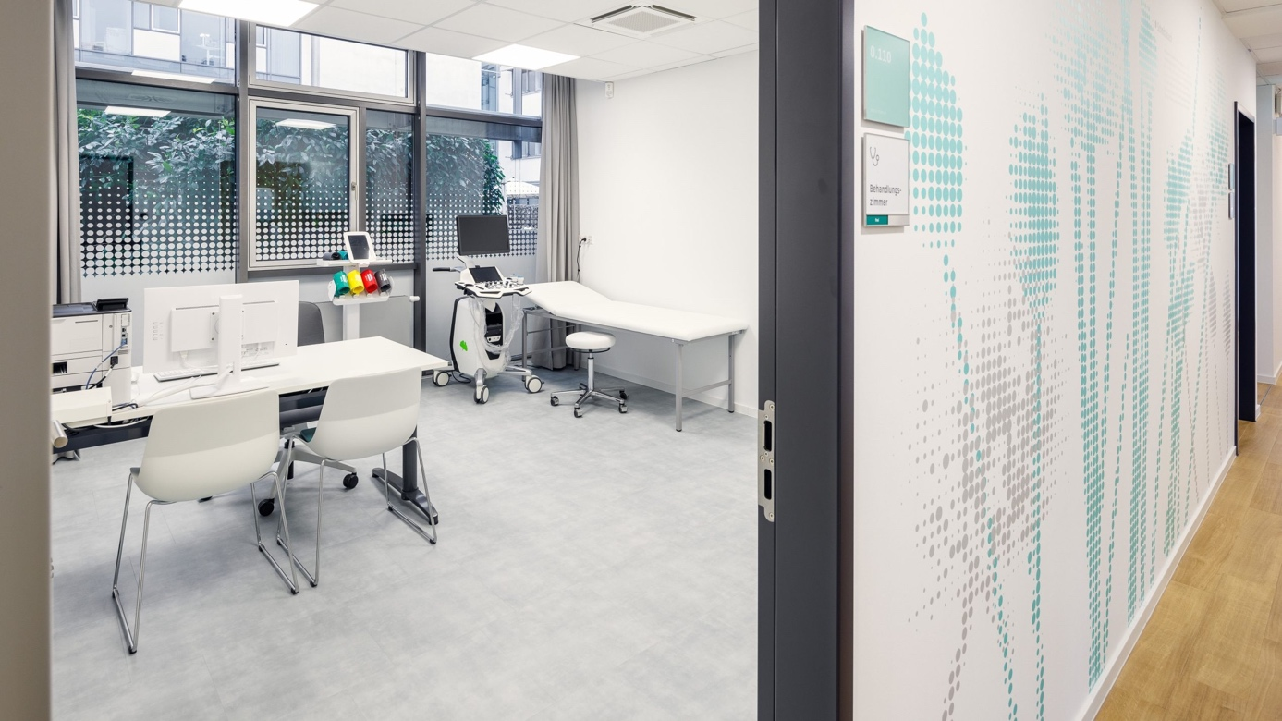

* **Top-quality medical facilities for Heilbronn region**
* **Relief for strained outpatient care**
* **Sana Kliniken AG turns to Schwarz Digits for cybersecurity**

January 7, 2025 will see the opening of "S | Medical Center", a new healthcare facility at Stiftsberg in Neckarsulm. The center will focus on primary and specialist GP care and preventative medicine, offering quick access to first-rate physicians and high-quality healthcare. "S | Medical Center" closes gaps in care, provides relief for existing medical facilities and supplements the healthcare services available in the Heilbronn region.

"S | Medical Center" will be operated by Sana MVZ am Stiftsberg GmbH, a Sana Kliniken AG company. The premises and the medical equipment will be leased from Schwarz Immobilien Service.

"We are pleased to be working with Sana Kliniken, a partner with experience and expertise," said Christoph Hopfenzitz, member of the Executive Board of Schwarz Operative Solutions. "This joint project to provide innovative and efficient healthcare solutions marks a significant step forward in efforts to improve the region's healthcare infrastructure. At the same time, it clearly illustrates the importance we attach to our employees and their health."

"Partnering with the companies of Schwarz Group marks a key milestone for us as a healthcare provider for corporate clients," said Thomas Lemke, CEO of Sana Kliniken AG. "We will be offering a wide range of healthcare services to employees of the companies of Schwarz Group, from preventative care through diagnostics down to best-in-class GP and specialist care. Ensuring that their employees receive good healthcare is becoming an increasingly important selling point as an employer for our corporate clients."

**Occupational Healthcare**

As well as primary and specialist care, "S | Medical Center" will also play a central role in providing occupational healthcare for employees of the companies of Schwarz Group. The companies of Schwarz Group already offer employees numerous medical benefits, such as a range of checkups, vaccinations and health advice. The medical center will gradually begin offering all of these services on site when it opens, and also plans to add additional services going forward.

**Sana Turns to Schwarz Digits for Cybersecurity**

As well as healthcare, the two partners are also entering into a pioneering IT partnership.  Sana is turning to the XM Cyber platform to provide round-the-clock protection against cybersecurity threats for its IT systems. XM Cyber is part of Schwarz Digits, the IT and digital division of Schwarz Group. This underscores their joint commitment to modern and secure healthcare that focuses on both patient safety and data security.

# Companies of Schwarz Group and Google to Sign Partnership to Jointly Deliver Sovereign, Secure Workplace Productivity Solutions for Germany and Europe

# Neckarsulm, November 14th, 2024

# Share article

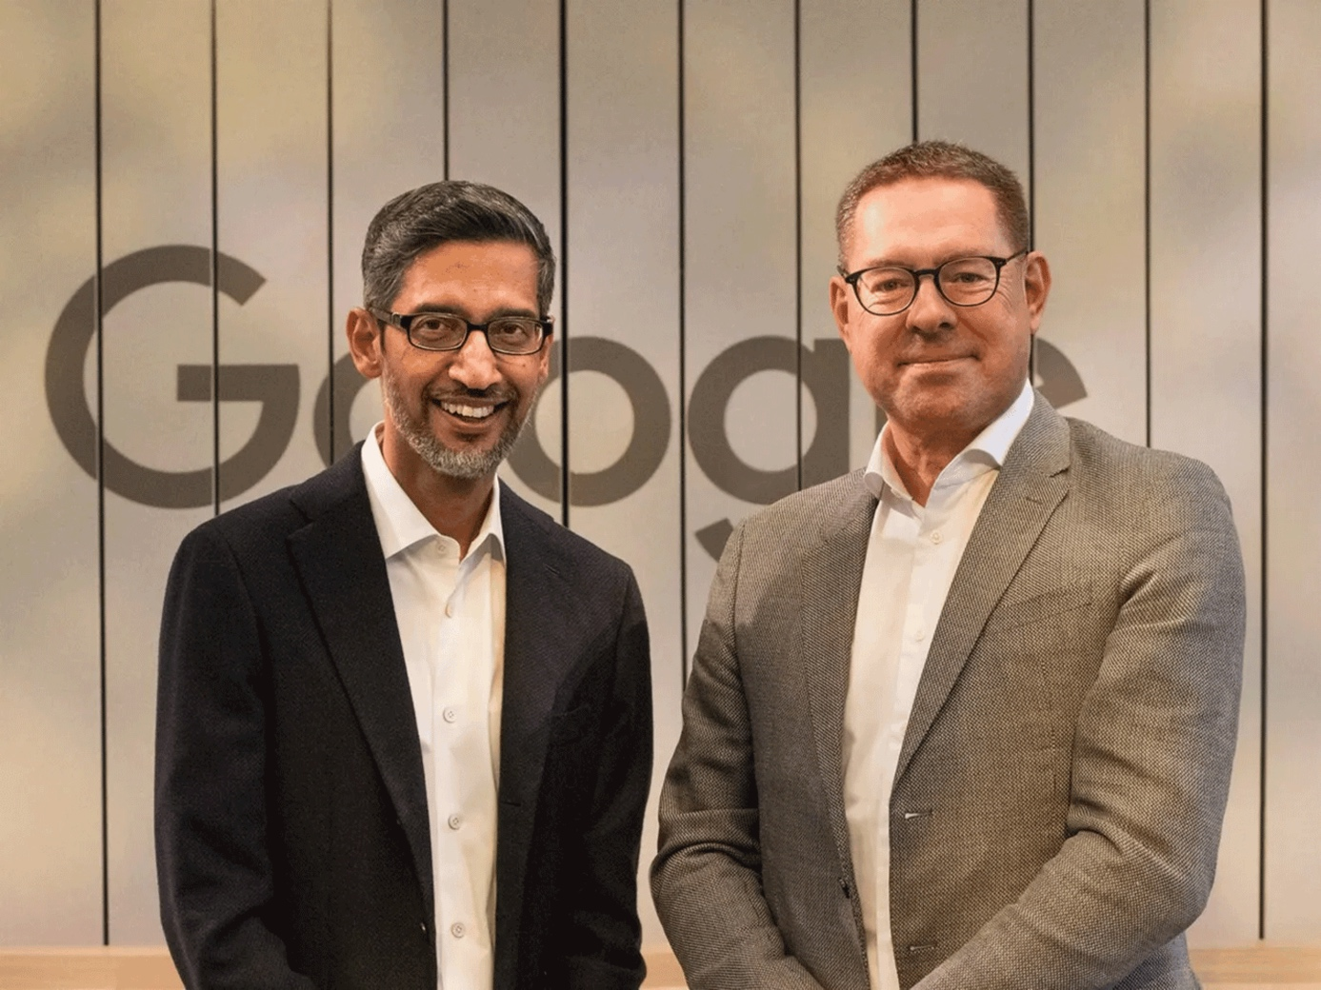

* Schwarz Digits’ Cloud STACKIT will provide local data storage for Google Workspace and offer client-side encryption, delivering a sovereign and secure workplace productivity solution with XM Cyber as enhanced security layer.
* The partnership will integrate XM Cyber’s Continuous Exposure Management with Google Cloud’s Security portfolio to develop new joint security offerings targeted at public and private sector organizations.
* The companies of Schwarz Group with 575,000 employees will transition to Google Workspace to maximize security, efficiency, and control of its data sovereignty.

Google and the companies of Schwarz Group today announced plans for a long-term partnership. The strategic partnership will cover major dimensions for secure and sovereign digital transformation, including best-in-class collaboration and productivity solutions and advanced cyber security offerings in Germany and Europe.

“For future viability in the digital age, it is essential to find partners who are truly willing to shape digitization together,” said Gerd Chrzanowski, General Partner Schwarz Group. “In Google, we found a partner that develops joint solutions with us on an equal footing, provides transparent insights and makes clear commitments. We’re looking forward to shaping digital transformation for Germany and Europe together with Google in a transparent, secure and sovereign way.”

“This new partnership will enable the companies of Schwarz Group to combine its leadership in digital transformation with Google Cloud’s strengths in productivity, collaboration and security, enabled by our cutting-edge AI,” said Sundar Pichai, CEO of Google and Alphabet. “Together, we are opening up a world of new, sovereign opportunities for European organizations to innovate and build on our joint solutions, accelerating a new era of innovation.”

Google Workspace in combination with Schwarz Digits’ Cloud STACKIT

The planned partnership will deliver truly secure and sovereign cloud-based collaboration solutions for German and European regulated industries, including financial services, healthcare, and the public sector. As part of the solution, STACKIT will offer customers the option to enable client-side encryption of their Google Workspace data – including sensitive and confidential data in regulated industries – through its own cloud platform, prohibiting third party access, including Google itself. Customers’ data will remain resident within the European Union (EU), with full redundancy offered by backups hosted solely in STACKIT’s European data centers to meet customer demands around data protection, data residency, and data resiliency.

“Germany and the EU have until now lacked enterprise-grade cloud collaboration solutions that fully address the sovereignty requirements of regulated industries, including ensuring all data is secured and backed up on local soil with absolutely no opportunity for access by foreign nations or platform providers,” said Rolf Schumann, Co-CEO of Schwarz Digits, the IT- and digital division of Schwarz Group. “Our partnership and new offering with Google Cloud will fill this gap with an entirely new business model.”

With client-side encryption, customers have sole control over their encryption keys—and thus complete control over all access to their data, and even Google as a platform provider has no access. This safeguards the sovereignty of not only the companies of Schwarz Group, but also all customers who value the independence of their operations, giving them full confidence that their data is always in their control.

Best-in-class offering for digital resilience with Google Cloud and XM Cyber

The partnership also addresses collaboration in the field of cyber security, with a goal of helping customers establish a strong foundation for cyber readiness and resilience.

First, Google Cloud’s security solutions will be integrated with those of XM Cyber, Schwarz Digits’ hybrid cloud security company, and the joint offering will be distributed to customers via the Google Cloud Marketplace. These advanced security solutions will help German and European organizations, particularly those in highly regulated industries, raise the bar on their enterprise and multicloud security. In addition, XM Cyber’s Continuous Exposure Management will be embedded into the sovereign Google Workspace solution offered to European enterprises.

“This partnership changes the game for regulated industry players in Europe by removing the sovereignty and security concerns that often hold back more ambitious adoption of the cloud for productivity and collaboration,” said Thomas Kurian, CEO, Google Cloud. “Our alliance with companies of Schwarz Group will enable entire industries in Europe to deliver digital innovation with security and compliance at its core.”

Workforce transformation at continental scale

The companies of Schwarz Group itself will adopt a similar approach as it transitions its global office workforce to the Google Workspace solution. This will ensure that critical workplace data can be protected against third party access including foreign government institutions, and also transferred to alternate service providers if needed.

“Switching to Google Workspace is an important step for us out of legacy and into innovative, efficient and future proof cloud-based collaboration,” said Christian Müller, Co-CEO of Schwarz Digits. “Google Workspace is the most secure and reliable productivity platform in the industry today, and we expect our organization-wide migration to have significant flow-on benefits to all areas of operations from simplifying IT management to rendering our point-of-sale workflows significantly more efficient.”

# Companies of Schwarz Group Commit to Reach Net-Zero by 2050 in Sustainability Report

Neckarsulm, September 19th, 2024

Share article

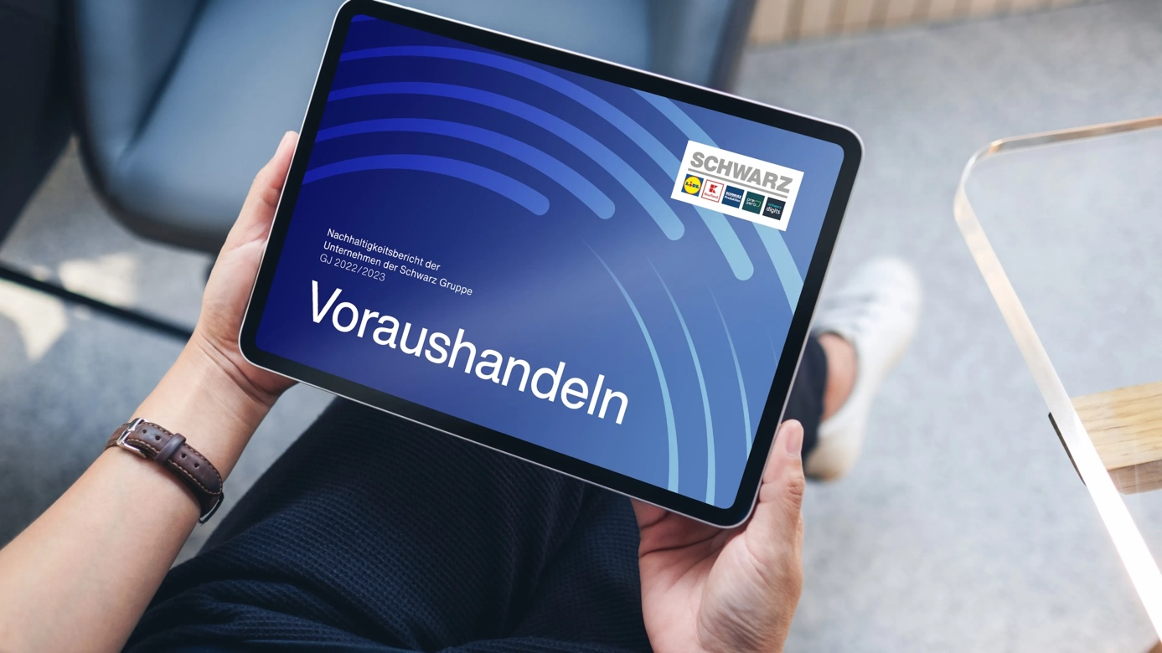

* Emissions down to net-zero by 2050: The companies of Schwarz Group submit a joint net-zero commitment to the independent Science Based Targets initiative.
* The companies of Schwarz Group are consistently driving forward their jointly defined sustainability commitment to people, the circular economy and the climate.
* The jointly created Sustainability Report of the companies of Schwarz Group informs on achieved reductions targets in the use of plastic.

Acting Ahead instead of just thinking ahead: In the Sustainability Report for the fiscal years (FY) 2022 and 2023, which was published today, the Companies of Schwarz Group inform on their joint sustainability commitment.

Ambitious Net-Zero Commitment by 2050

As one of the leading global retail groups, the companies of Schwarz Group are aware of their responsibility to climate protection. They joined the Science Based Targets initiative (SBTi) back in 2020. Now they are taking the next logical step and are submitting a joint, official net-zero commitment to the SBTi. As such, the companies of Schwarz Group are committing themselves to reducing all emissions generated in their own companies and along their value chain to net-zero by 2050 at the latest.

Furthermore, the companies of Schwarz Group are supplementing their existing, jointly approved supplier engagement with absolute reduction targets in the upstream and downstream supply chain by 2034 and are working together with their respective suppliers to implement these. Using the 2022 base year, indirect emissions in the agriculture and forestry sector will be reduced by 42.4 percent and a 35 percent reduction will take place in the energy and industrial processes category. By 2030, the operational emissions in scope 1 and 2 are to be reduced by 48 percent (base year 2019). In the next step, these new climate targets will be validated by the STBi.

In order to achieve their ambitious targets, the companies of Schwarz Group are implementing manifold measures: For example, in FY 2023 they used a total of 598,700 megawatt-hours of self-generated renewable energy. This includes a surface area of more than 4,000,000 m² for photovoltaic systems. That is equivalent to the size of 568 soccer pitches.

Thirty-four Percent Less Plastic Used in Private-label Packaging and Transport Aids

Another jointly declared target of the companies of Schwarz Group is the dedication to the circular economy to conserve resources and close recycling loops. In the course of the jointly developed “Reset Plastic” strategy, the companies of Schwarz Group reached new milestones in the 2022 and 2023 fiscal years: Since the 2017 base year, they were able to reduce the use of plastic in private-label packaging and transport aids by 34 percent. As such, they exceeded the original reduction target of 30 percent by 2025 as early as FY 2023. Moreover, the recycled materials content in private-label packaging made of plastic was increased to 19 percent. The prospects are bright for reaching the intended figure of 25 percent recyclate content by 2025.

Joint Sustainability Report Creates Transparency

General Partner, Gerd Chrzanowski, explains why sustainability plays a central role in his eyes: “As companies of Schwarz Group, we do not wait for challenges to become problems. We act ahead in order to secure a sustainable, healthy and safe life for billions of people. We create transparency with the aid of our Sustainability Report and integrate all stakeholders into our joint commitment to sustainability.”

Report Structure

The jointly created Sustainability Report of the companies of Schwarz Group, which was released on September 19, 2024, covers the period from March 1, 2022, until February 29, 2024, and thus includes two full fiscal years (2022 and 2023).

Additional Information

You can find further information and the current Sustainability Report of the companies of Schwarz Group on the newly designed website [www.sustainability-report.schwarz](https://www.sustainability-report.schwarz/).